Feature Release Note



C

ONTACTS

info@uppwise.com

[l](https://www.linkedin.com/company/uppwise)

[LinkedIn Company Profi](https://www.linkedin.com/company/uppwise)

[e](https://www.linkedin.com/company/uppwise)

[m](http://www.uppwise.com/)

[o](http://www.uppwise.com/)

[www.uppwise.c](http://www.uppwise.com/)

This serves as a Feature Release Note to apprise our customers of the latest addition to the application, released with the Uppwise 2023 Quarter 4 release (**23.4.0.0**).

# Feature Title: Implementation of Gen AI in SPM Strategy Module

A new groundbreaking feature has been introduced called Co-author in the Strategy Module, which harnesses the power of Gen AI. This innovative tool is designed to generate comprehensive information related to the Strategy module, including summaries, missions, visions, milestones, themes, OKRs (Objectives and Key Results), and more.

**Below are few key points of this feature:**

* + Accessibility permission is added over User profile related to Co-Author.

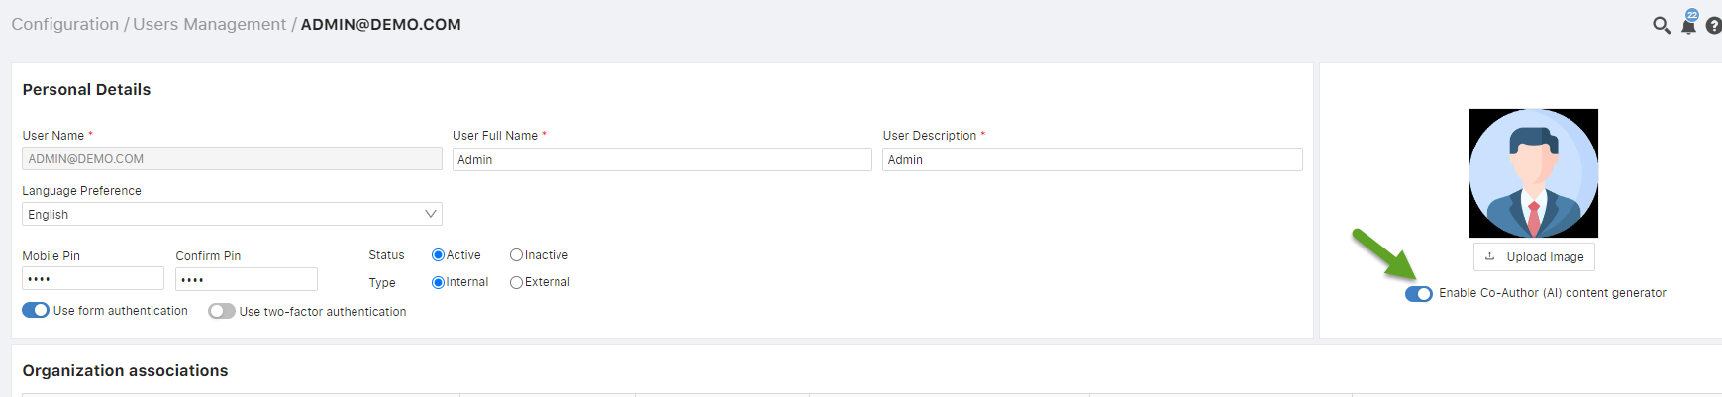

* Users granted the above permission will gain access to the Co-author functionality by identifying the Co-author icon (Chat window – referring in below screenshot) positioned conveniently over the Strategy interface, enabling seamless utilization of its features.

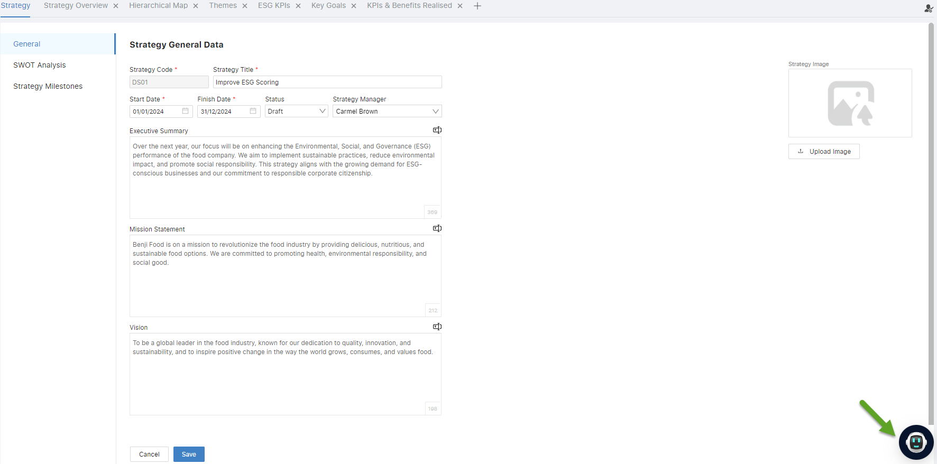

Chat window:

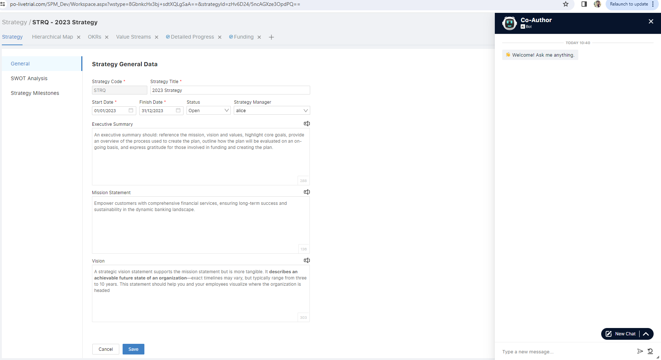

* The chat window offers convenient prompts tailored to the content being discussed. For instance, when navigating a detailed page, users will find prompts such as Summary, Mission, and Vision for quick access. When exploring milestones, they'll be presented with options like 'Suggest Strategy Milestone,' and when delving into themes, a range of relevant prompts will be available for seamless interaction.

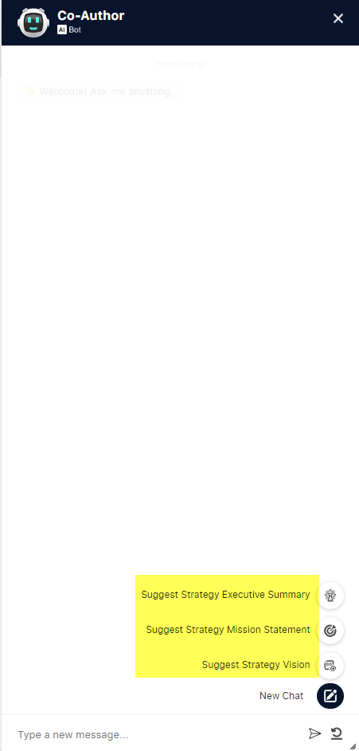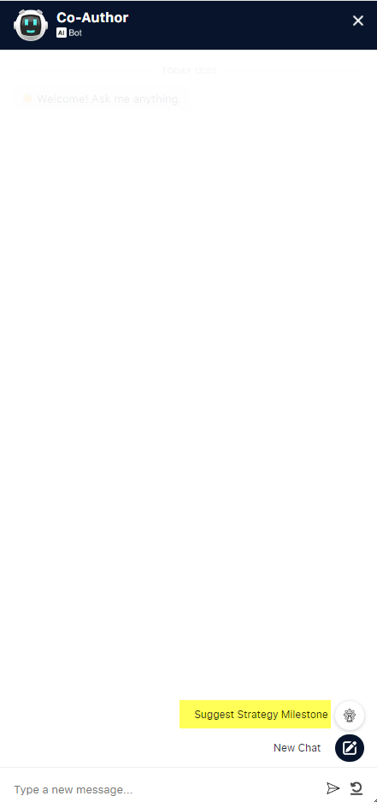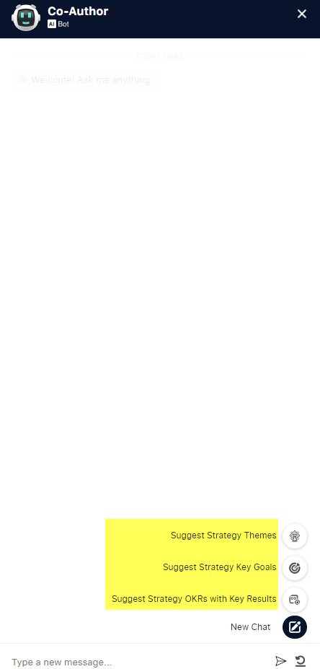

* Below Sub-features are implemented with Co-author:

**1: Generate Comprehensive Strategy Content**

* Co-Author dynamically generates content for the Strategy Detail Page, including Executive Summary, Mission Statement, Vision, and SWOT Analysis.
* The generated content aligns seamlessly with the input provided by users.
* Users can easily view and edit the generated content within the SPM solution.

**2: Automated Strategy Milestone Suggestions**

* Co-Author suggests key milestones for the implementation of the defined strategy.
* Suggested milestones align with the overall strategy and objectives.

**3: Strategic Themes and OKRs Recommendations**

* Co-Author recommends Strategy Themes and associated Objectives and Key Results (OKRs) to support strategic planning.

**4: Automated Strategy Key Goals and OKRs Recommendations**

* Co-Author provides recommendations for Key Goals and associated OKRs with Key Results to support strategic objectives.

**5: Automated Project and Task Suggestions**

* Co-Author offers suggestions for projects and associated tasks aligned with the defined strategy.
* Users can easily incorporate Co-Author's project and task suggestions into their project planning process.

**6: Intuitive Drag and Drop Feature for Direct Saving**

* Users can easily save generated content into the SPM application through a simple drag and drop feature.
* Enhances user convenience by providing a direct and intuitive saving mechanism.

**7: Portfolio Association**:

* + Co-Author facilitates the association of projects with specific portfolios within the SPM solution.
  + The association mechanism ensures efficient organization and tracking of projects within the broader portfolio context.

**8: OKRs Review Cycle Association**:

* Co-Author empowers users to associate Themes, Objectives, and Key Results (OKRs) with specific review cycles for comprehensive performance management.

**9: Direct Assignment from Cards to Owners or Managers:**

* Users can directly assign owners or managers to specific objects such as milestones, themes, and OKRs from cards.
* Introduce a search functionality where users can identify and assign owners or managers by typing "@" followed by their names.

**10: Measurable Values for Value-Based Key Results:**

* Enable users to obtain measurable values specifically tailored for value-based key results within the SPM solution.

**11: Initiative Type Preference Setting:**

* Introduce a preference setting in the Co-Author configuration page, allowing users to specify their preferred initiative type (e.g., project or epic) when saving projects in the SPM application. This customization enhances user experience and ensures seamless integration with their preferred project categorization.
* **Co-author setting on company page:**

A new setting is added over company page to define the all-relevant information. User can enable his own custom model for content generation.

